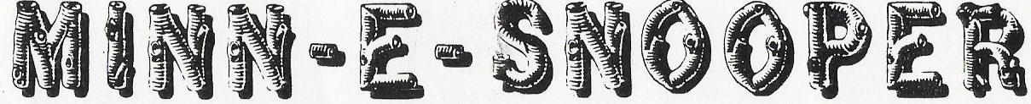

NSDCA 068 WANDERING WHEELS, LTD- Square Dance Camping Club August 2017

Our August 2017 Wandering Wheels Campout was in St. Peter at the Nicollet County Fairgrounds. We had 25 rigs! Several belonged to guest campers who joined us for the weekend. Friday’s dance had over 6 squares in attendance.

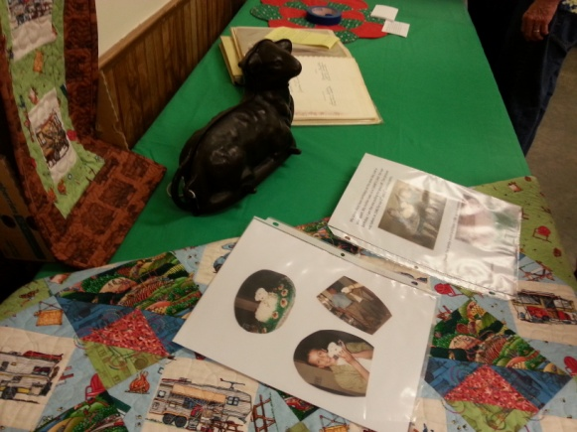
The theme this month was “Nostalgia & Tradition”. Friday afternoon the tables were already set-up showing some of the meaningful items people brought.

Here’s Carol with a funky potato. I don’t think that was part of the theme, but it is an interesting little creature
Before our dance Friday night we had some time to socialize, and here’s Carol, Jan & Nancy doing just that! Looks like Maynard is putting out the scrapbook of his classic cars.
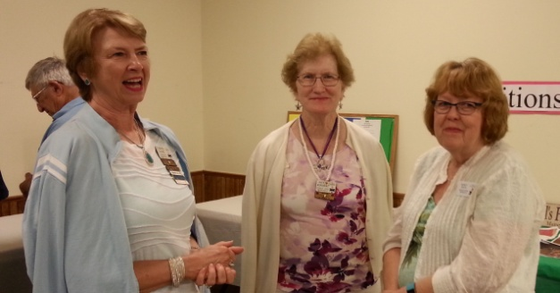
Larry Fruetel called our dances this weekend and on Friday evening he changed it up a little with a polka.

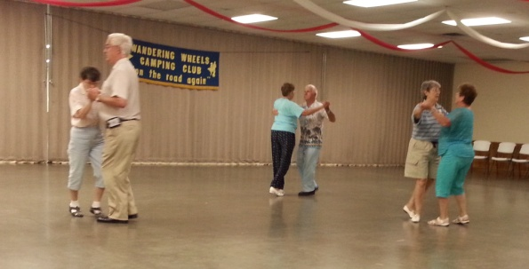

Wandering Wheels has many members who are also members of Hotfoot Stompers, plus this weekend we had some extra Hotfoot Stompers camping with us. Here’s a group picture of all of them at the dance Friday evening.

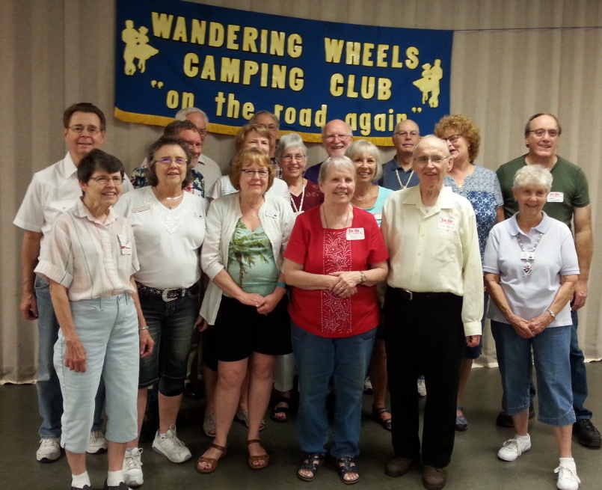
Special thanks to Queen Rosemary of Hotfoot Stompers for driving all the way down to St. Peter for our Friday night dance! Thanks to members of the St. Peter club who also came and danced with us, and to John and Rose Cook from Dakota Grand, who spent the weekend camping with us.

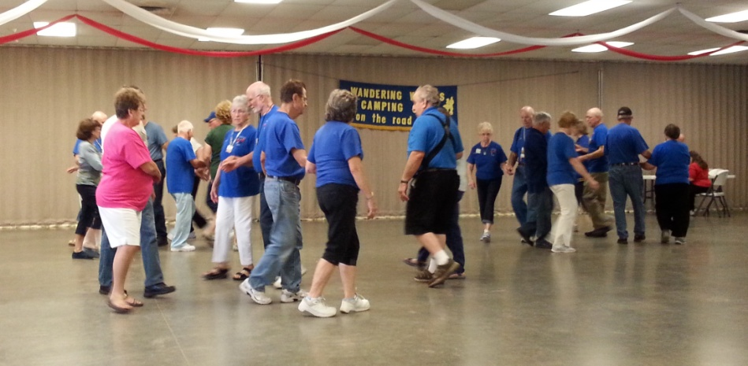
We had a great turnout at the campfire Friday evening, and after a good night’s sleep, we were ready for our business meeting and workshop Saturday morning. Larry taught us some great calls: Rainbow Stroll, Grand Parade, Grand Star Thru and Girls or Men Face Grand Square. That one made us realize how much we depend on our partner!

Jackie Mann, Tim Hanson and Pat Ekstrom were in charge of games in the afternoon. Our game was Life Stories and we had three choices of categories to choose from: Memories, Valuables and Etchings. It tied in nicely with our theme for the weekend, as many told memorable stories that brought smiles to our faces. Thank you Jackie, Tim and Pat.

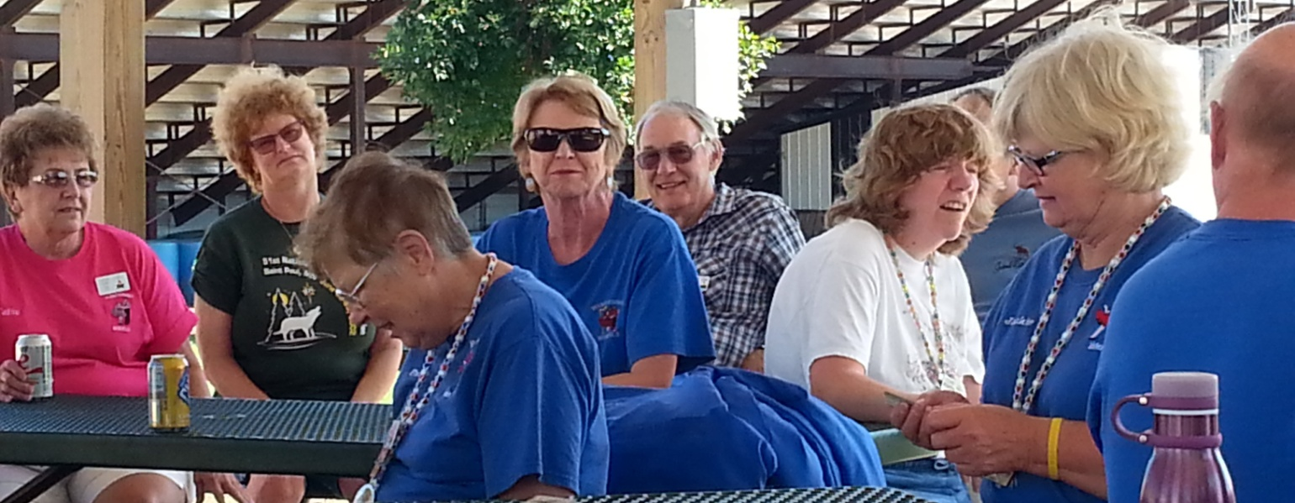

After the organized games, some members played Bocce Ball or cards, some worked on the jigsaw puzzle and Linda Marcotte taught a couple of us how to make a Pony Bead Chain for our name tag. Thanks Linda!
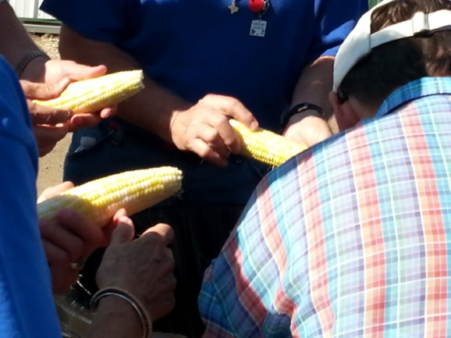
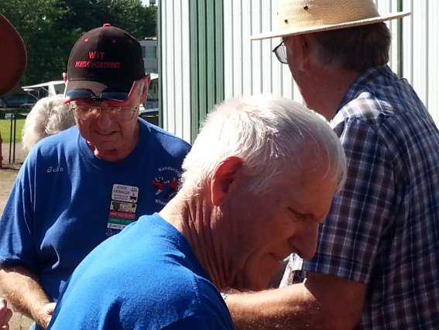
Saturday dinner was our annual corn feed. Of course we had potluck too, so there was lots of food. Corn husking started at 4:00, and by 4:06 it was done!

These guys sure work fast!
Before our potluck, Carol Dahl asked us to share a little about the item we brought and tell why it was memorable. There were some great stories shared.

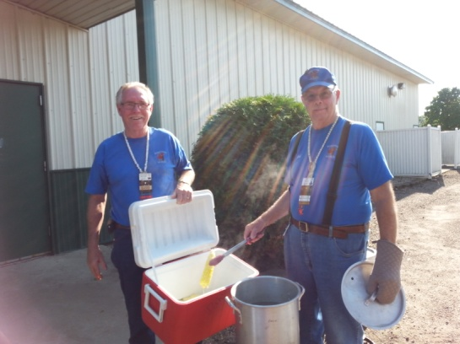
Then it was time to eat corn. Great job of cooking, Don and Bob!

Thank you Larry and Vicki for spending your weekend with us!
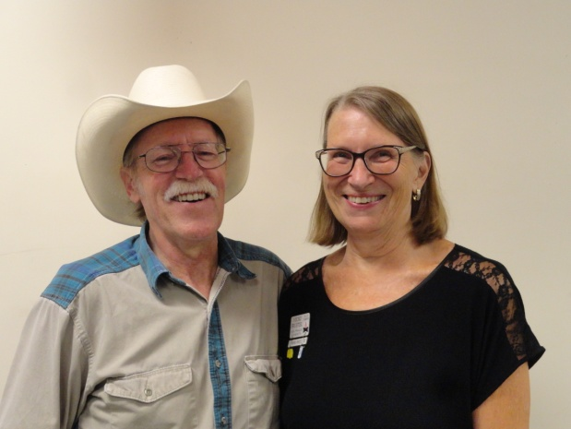

For our evening dance, this lovely couple joined us. How much more creative can you get?
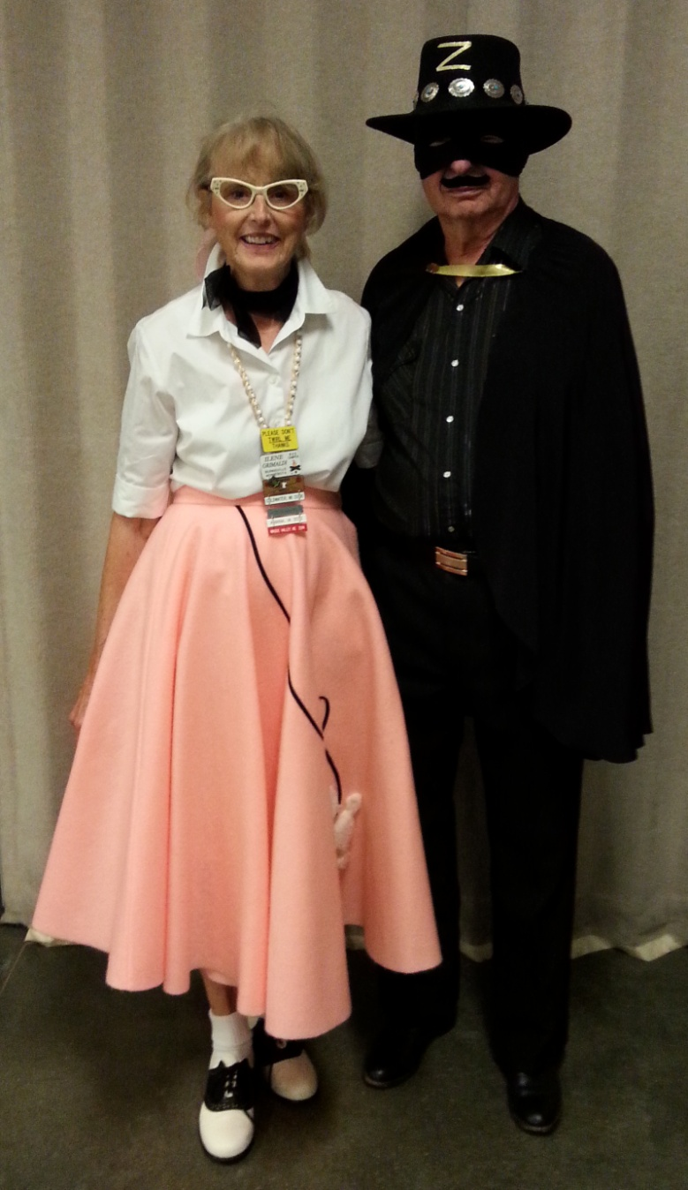

We also had the honor of having Tim call with Larry. Nice job to both of you!
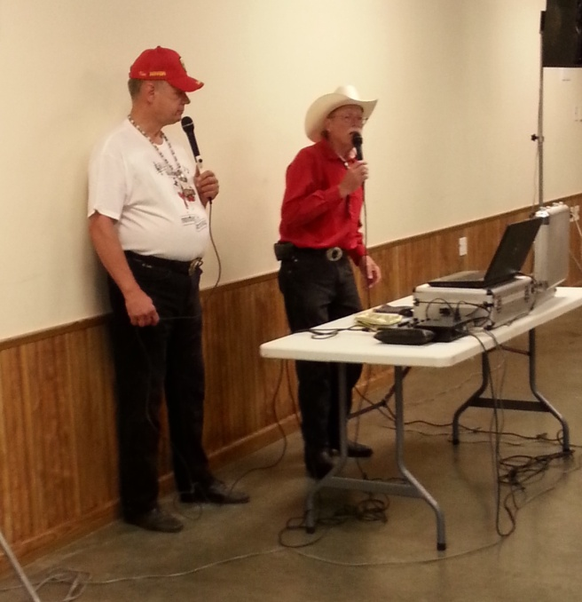

We ended the night with another campfire that was well attended. What happens at the campfire stays at the campfire!

Respectfully submitted by,
Sally Carlson

