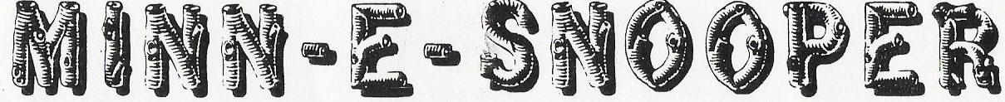

NSDCA 068 WANDERING WHEELS, LTD- Square Dance Camping Club August 2018

Our August 2018 Wandering Wheels Campout was in St. Peter at the Nicollet County Fairgrounds. We had 19 rigs! Several belonged to guest campers who joined us for the weekend. We had 4 squares of dancers on the floor most of the weekend.

The theme this month was “Health Care Providers” and we had an amazing array of medical information and supplies displayed. Thank you Ekstrom’s and Grimaldi’s for your creativity in displaying all this and bringing it all to the campout.

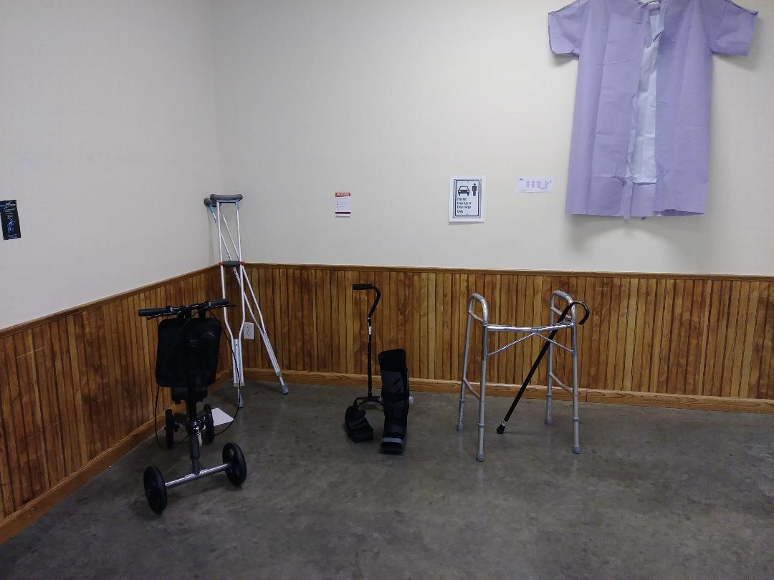

Larry Fruetel called our dances this weekend. Thank you Larry and Vicky!
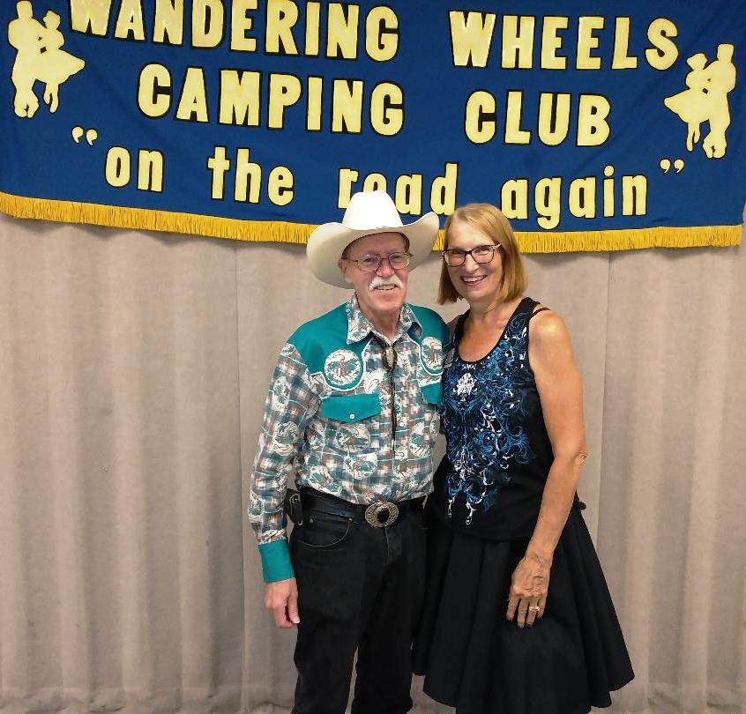

We had three guest couples who joined us for the weekend. Bill and Gail Bump, Gene and Joy Johnson and Jerry and Pat Rozelle. Gene and Joy became our newest new members. Welcome!

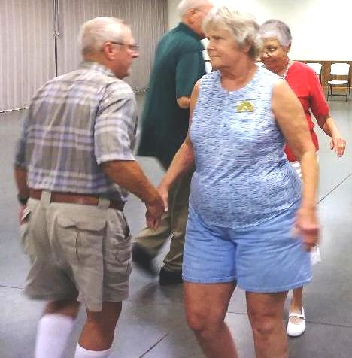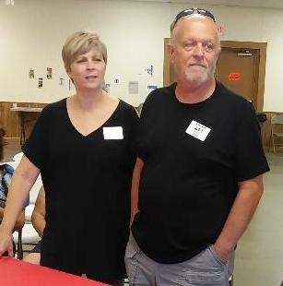

Bill and Gail Gene and Joy

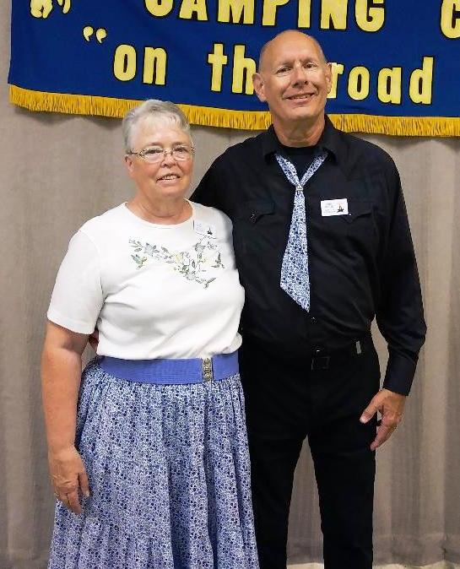
Jerry and Pat Rozelle are full-time RVer’s who were traveling in the area and joined us for the weekend. Maybe some of you will run into them again on your travels.

Some of our Friday Evening Dancers:
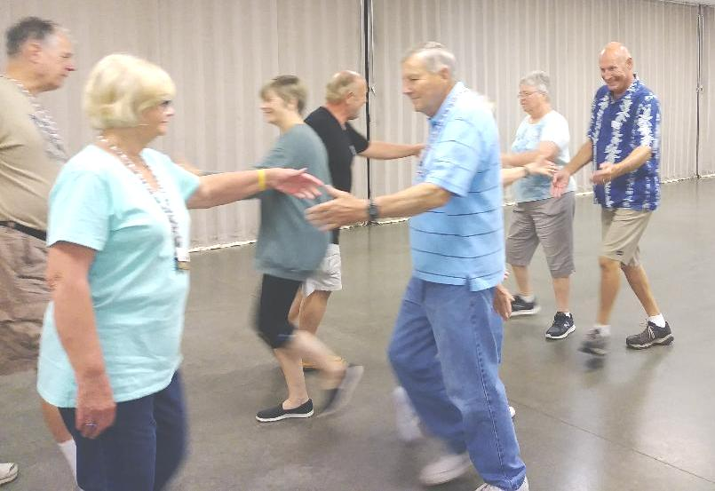
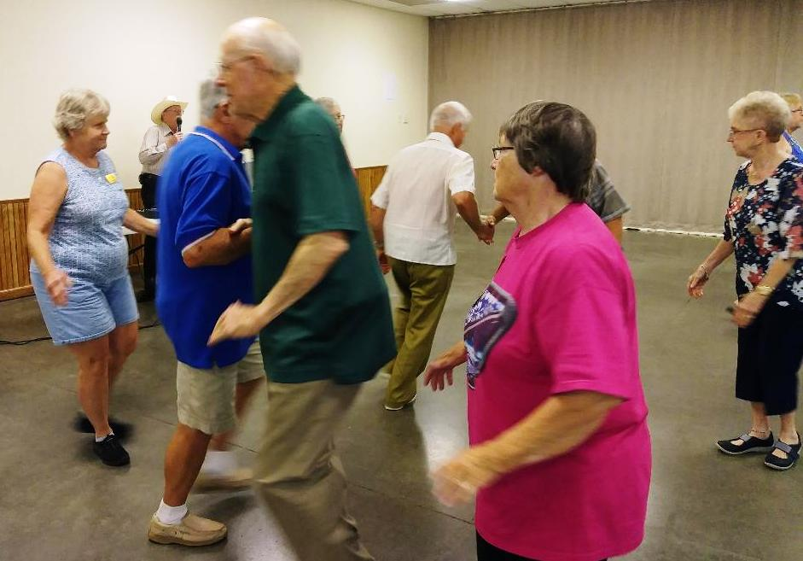
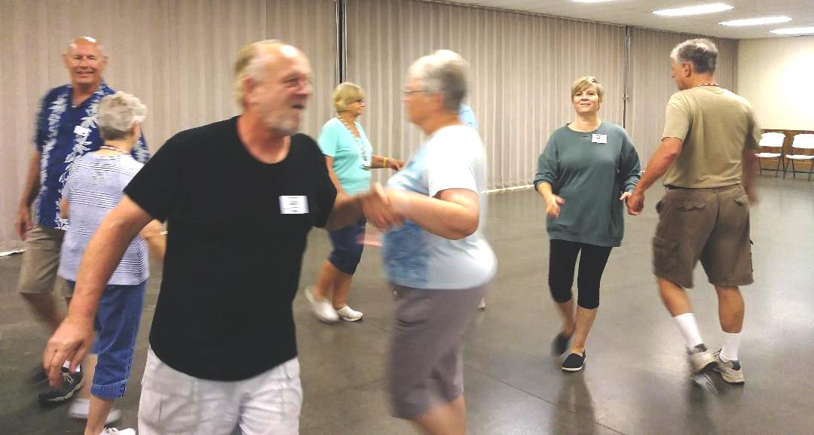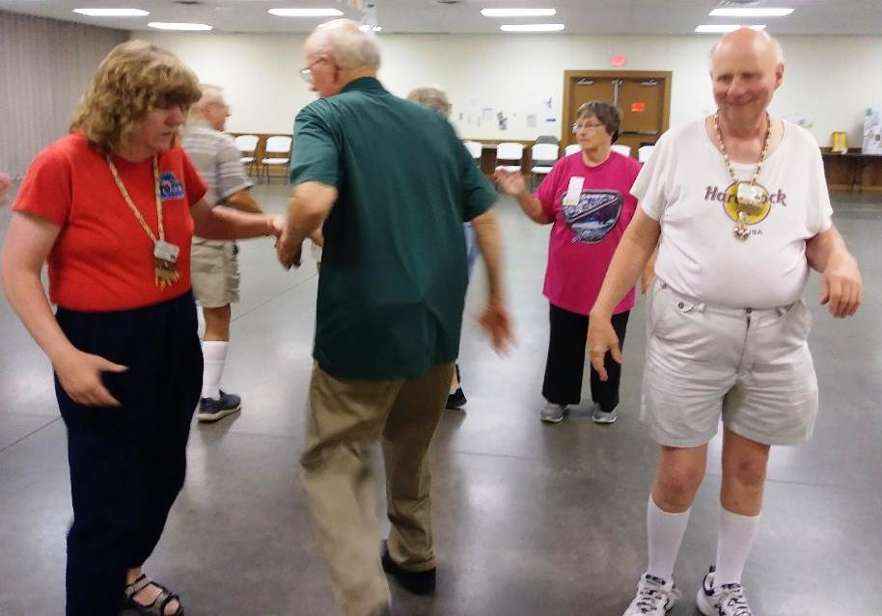

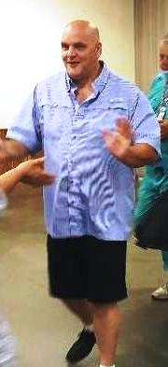
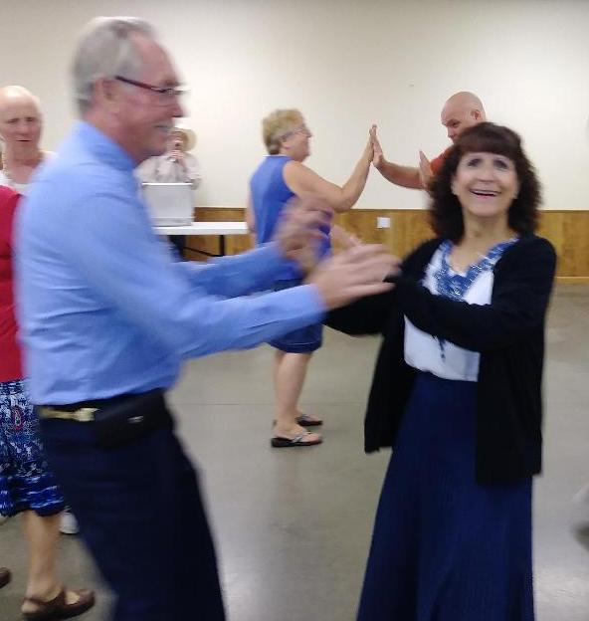
We had a great turnout at the campfire Friday evening, and Lee Hill kept us entertained with stories of his 40+ years of dancing! Yes, he started dancing really young!

After the business meeting Saturday morning, Larry work-shopped left-handed calls. After a break for lunch we were back in the hall for ‘Camping Feud’.

Lynn and Don Webster did a fabulous job with all the game boards and other details to put this together. I think every team of 4 won at least one game. We had lots of laughs and ‘huh’ moments trying to figure out how some of those answers were in the top 100 people surveyed. Thank you Lynn and Don for all the time you put into this!
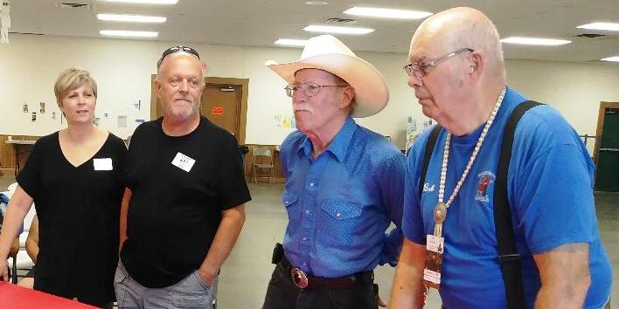

CAMPING FEUD
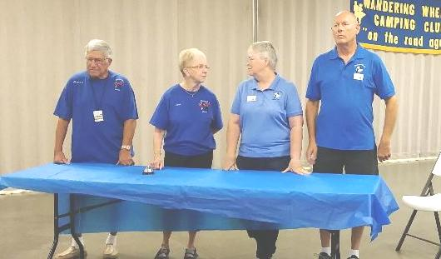

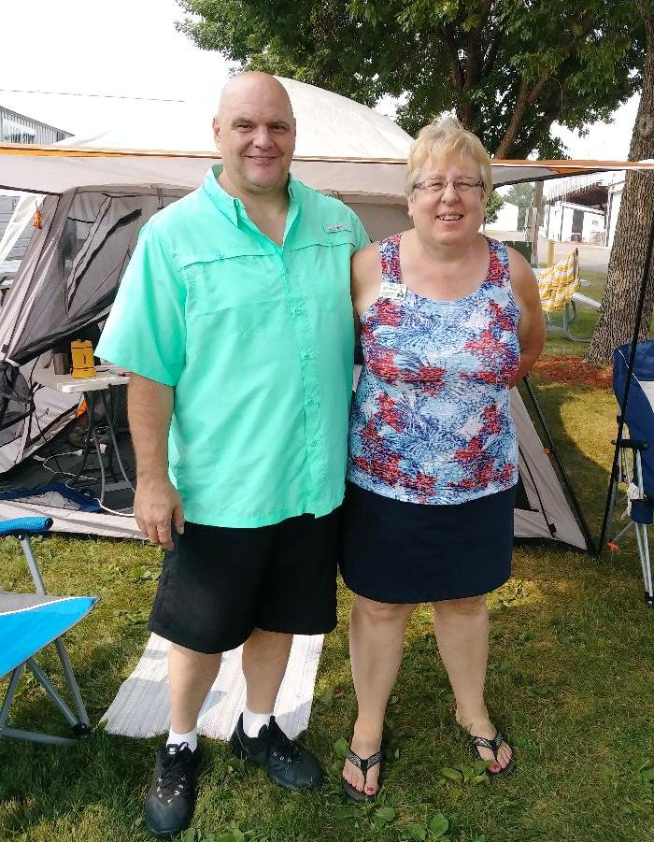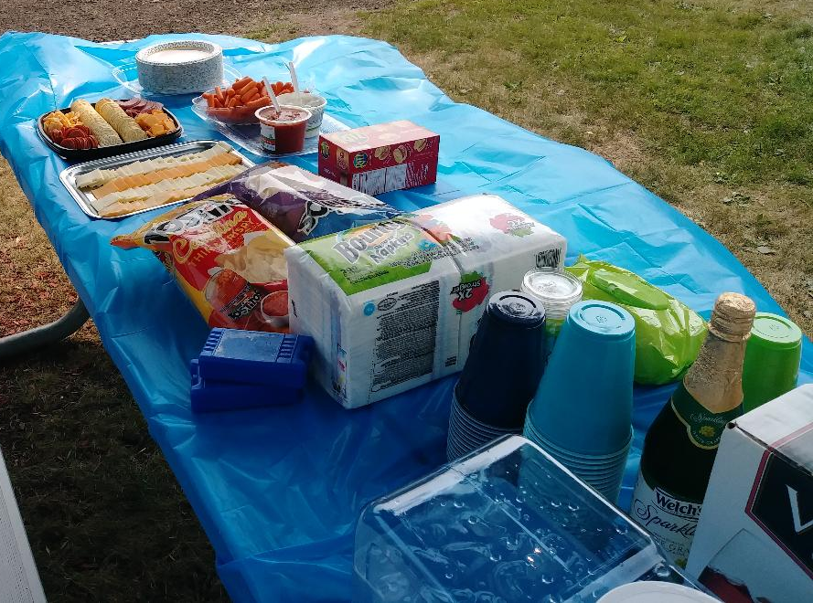

After games we had the honor of attending another open house. This time it was Lee and Linda showing off their new digs and of course more food!
Saturday dinner was an eating healthy potluck. We are a creative bunch when it comes to cooking. Everything was very good, even if it was ‘healthy’. Some of our attendees at the dance Saturday didn’t look so healthy though!

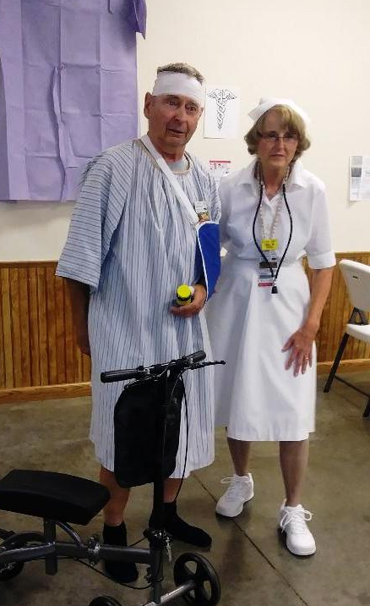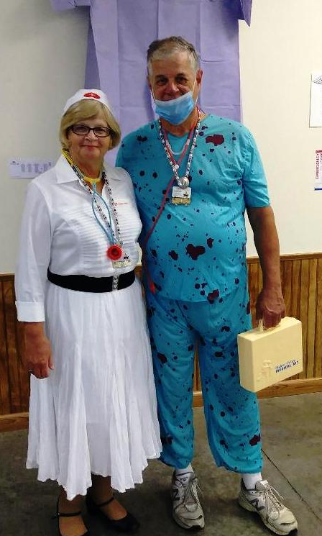

We welcomed several guests to our Saturday Evening Dance.

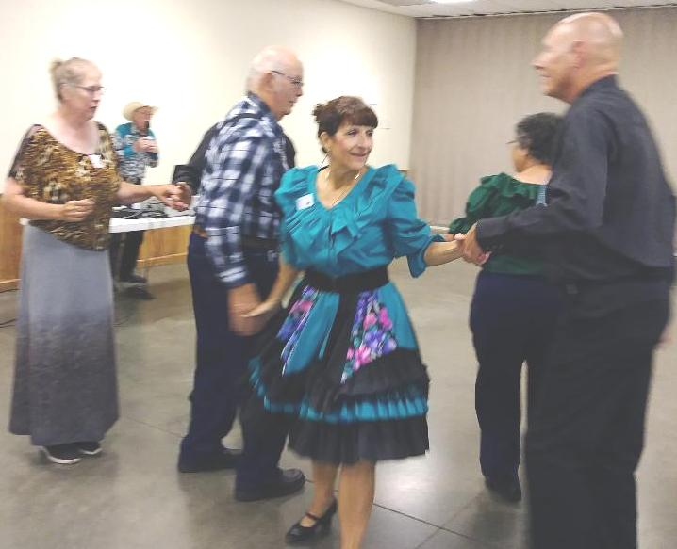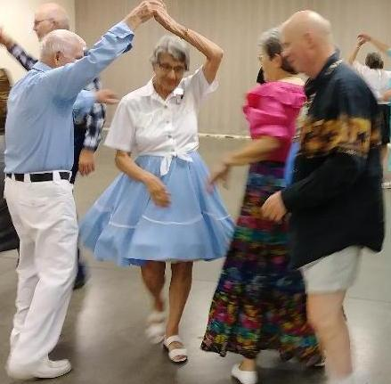

Respectfully submitted by,
Sally Carlson

