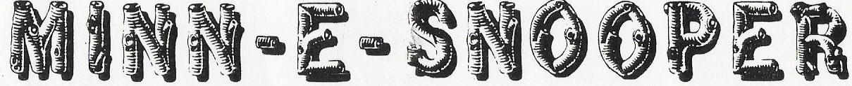

NSDCA 068 WANDERING WHEELS, LTD- Square Dance Camping Club July 2017

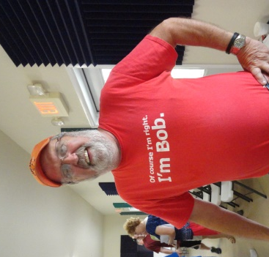
Friday, July 20 Keyes’, Dahl’s and Bob Sadler decided to meet at Lowes in Blaine and Caravan to Rochester. Since Hwy 52 down by Cannon Falls to Zumbroto was under construction, we opted to take a different route. A Hwy 65 traffic light just gets one vehicle across from a side street. We radioed to Bob to get on Main Street/242 once he gets on 65. We kept talking and nothing from Bob. One mile into our caravan and we lost Bob. It wouldn’t have been so bad that Bob was out of CB range, but just before we all loaded up to start our drive, Bob said…”I forgot my cell phone at home”. So there was no way to communicate with Bob. One never realizes how lost you are without a phone, until you don’t have it. Thank goodness for Roger’s CB and its long range, we finally picked up communication and met Bob outside of Owatonna at a rest area.
Most people got set up before the rain. It was very warm and humid. After the rain, the sun came out and made it even stickier. We had 21 units for this month’s campout. That has got to be almost a record. Of course having the “infamous” Bob Asp as our caller for the weekend, we are sure that is what drew the crowd.
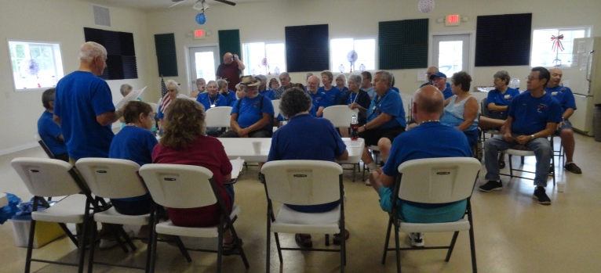
The joys of owning an RV seems to come with “little incidents” that need to be fixed and taken care of. This weekend Ted and Sally’s refrigerator wasn’t working, so back to coolers and ice, or the help of other campers with large refrigerators. Somehow Tim’s bathroom door got locked and no one was in there. They did not have a key, so they ended up taking the whole doorknob off and replacing it. Thank you Bob Sadler for helping with that. Also, our new visitor’s Jerry and Fran realized a valve to the hot water heater was broke. Good thing Hilltop Camper and repairs is just up the road. Everyone got things repaired and supper eaten in time for the Friday evening dance. Another record broke with five squares for mainstream and four squares for plus. Thank you to the Mocha Crunch Square Dance Club who showed up with nine members.
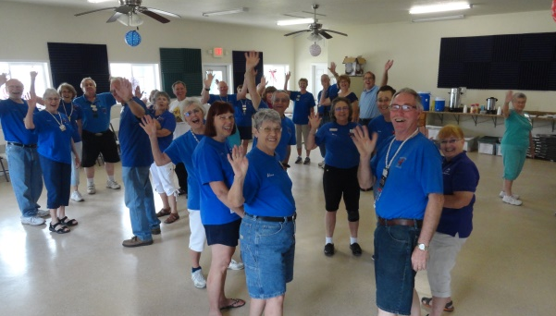
Saturday Morning we conducted our monthly meeting. Everyone was working at getting in their seats or getting coffee and snacks. Cathy Quam was vacant from her chair when Chuck hollered (in his usual fashion)…”Cathy, your vibrator is going off, oh, I mean your phone is vibrating.” Ha!
After the meeting Bob did our workshop. We had a record showing of four squares to do the workshop. It was a very good workshop. We learned how to do “scoot back” in different positions. Also, “trade-by” and “split circulate”. Tim was helping Ted, and at first Tim thought he was wrong, then Bob Asp did admit and announced to all that Tim was right. That made Tim’s day.
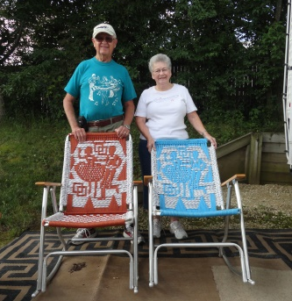
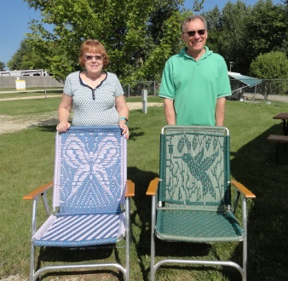
Our past Wandering Wheels members, Ray & Sue Barker, donated four macramé’ chairs to the club that were made by Peggy Decker. Sue said get whatever you want for the chairs and keep the money. I think we could have had a bidding war, but 1st come, 1st serve and the lucky recipients for the straight chairs were Jerry & Nancy Knoth. For the rocking chairs, Pete & Barb Putnam purchased those. $130.00 was donated to the club for all four chairs.
Tom & Mary Simco were in charge of games for the afternoon. Our games were “Urban Myth”, “Worse Case Scenario”, and “Are You Smarter Than a 5th Grader. We had two teams. Team one won the round of “Urban Myth” and team two won the round “Are You Smarter Than a 5th Grader”. Our third round was a tie when we played “Worse Case Scenario”. Everyone goes home a winner. Candy was handed out to all. Thank you Tom and Mary. After the organized games, some members stayed in the hall and played cards and Linda B. had a few interested in learning how to play “Banana Grams”. Now that is a game that is great for us “seniors”. Keeps your mind thinking!!
Just before the Saturday evening dance, storm clouds started gathering. After another shower Jackie captured a beautiful picture of a rainbow.
The Saturday evening dance was high energy. As we all know, a caller does not miss anything that goes on during a tip. Bob was singing “Wagon Wheel” and our young dancer Zach’s hat flew off. Bob continued calling square through four and pick up your hat. They never miss a thing.
During the announcements we found out that our new visitors Jerry Steinworth and Fran Sorenson joined the Wandering Wheels Club. They are also members of Hotfoot Stompers. Welcome!
It was so humid; it was tough keeping the temperature comfortable in the building. The decorations were getting droopy and Bob kept telling us that his “half balls” keep dropping. Don’t ask!!!
Monica is usually right on top of taking all the necessary pictures, but this weekend she forgot to get a picture of both Bob and Cinda together. My apologies Cinda. Wish I knew how to “photo shop” you in!
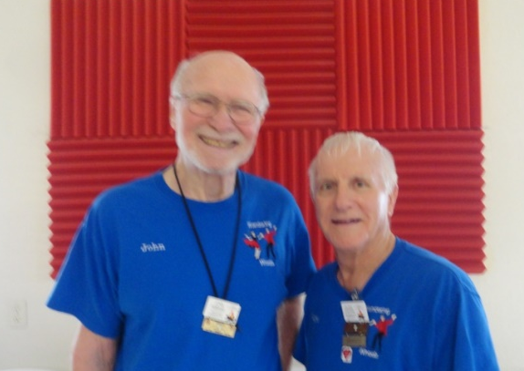
It was a real treat having the Asp’s with us and Bob did a great job of keeping us hopping. He also did a “brilliant” job at stirring the bucket all weekend! Don’t know if anyone else noticed, but I sure did.

Congratulations and a BIG shout out to John Hibbard and Floyd Ekstrom for receiving the “Young at Heart” awards this year. I think you have to be 80 years or older!! Keep it up guys!

Respectfully submitted by,
Monica Keyes

