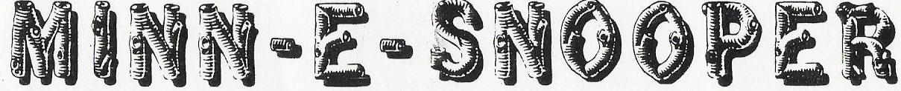

NSDCA 068 WANDERING WHEELS, LTD- Square Dance Camping Club May 2019

Our Memorial Weekend Campout was in Cambridge Minnesota at the Isanti County Fairgrounds. We had 21 rigs, which included five guest couples. Our great caller Tom Allen and wife Sally helped draw many walk-in dancers, like almost 100 of them! Some came to all 3 dances and a few attended one of the bonfires. All in all it was a great weekend!

The theme this month was “Chinco de Mayo” and “don’t forget your wife’s duffle bag”! Ilene can tell you about that! It was a long drive back to Burnsville Friday evening!

Our guest camping couples included Bill and Gail Bump who brought their snazzy new ebikes with them. Louie and Carol Jaskulka are new dancers who were hosted by Gene and Joy Johnson.
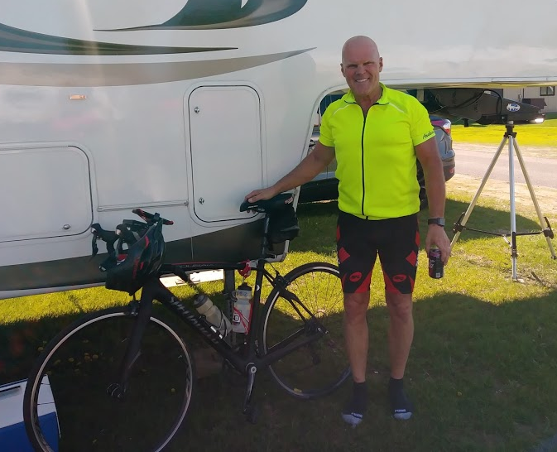
Louie is training for the Minneapolis to Duluth MS Bike ride and on Saturday he biked to Princeton and Sunday he biked towards Mora, as far as time would allow. Here he is upon his return on Sunday.

We also welcomed two couples whose names are Wayne and Karen. Wayne Lehmann and Karen Henning spend a couple weekends each year camping with us and we are always happy to have them. Wayne Duerfeldt and Karen Stoller are new dancers who are interested in joining Wandering Wheels so we look forward to having them in our club.

Our other guest couple was Ken and Carolyn Shacter from Florida. It was fun having them with us also.
At the business meeting Saturday morning, Linda Biederman-Hink had us form a circle and then we each introduced ourselves and gave a little information about us including our favorite camping spot. There are a lot of different favorites. Makes me want to get out there and see some more country. This was a great way for us to get to know something about our guests and vice versa.

Saturday afternoon was a bit cloudy and cold so we decided to play games inside. There was a game of Mexican Train Dominoes going on as well as Rummikub and a card game or two. Some of the campers decided to rest or do their own thing this time. Sunday was a little nicer so Don and Monica Keyes got out the yard games.

We had a special dinner Saturday night. Linda Biederman-Hink’s favorite meal growing up was New Mexico style enchiladas. This was a layer upon layer of chili, tortillas, and your choice of toppings. It was amazing! We ate so much and it was oh so good! We also learned our colors in Spanish if we wanted to eat, since that’s how the tables were called.

Our usual two couples outdid themselves once again, dressing for the weekend theme.
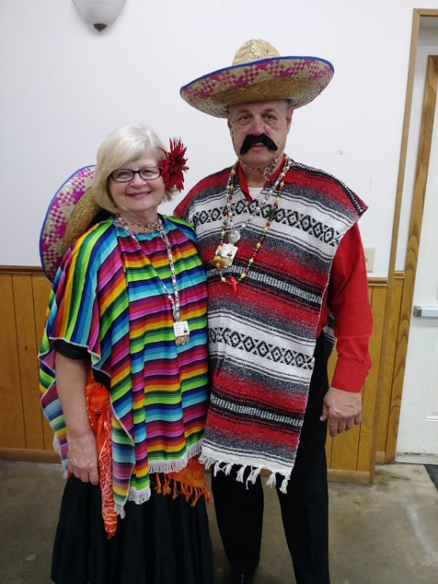
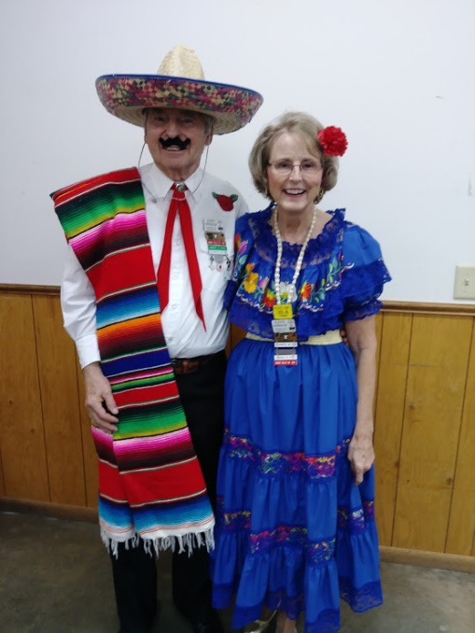

Jackie Mann and Tim Hansen John and Ilene Grimaldi

We had another lively dance Saturday night with many walk-ins from the area.
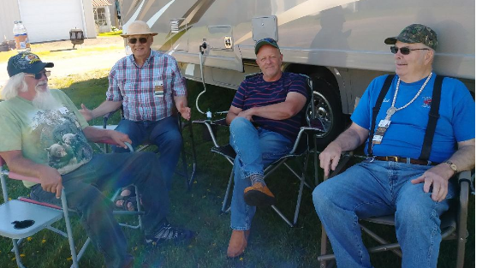
Sunday started out with a potluck breakfast that was very good. We were on our own for the afternoon. Here are a group of guys trying to solve all the world’s problems. Think they’ll be successful?

Ted Fjoser, Roger Dahl, Gene Johnson and Bob Sadler

We had a pizza party for our Sunday meal and boy did we down the pizza! It’s amazing how much food this group goes thru in a weekend! Guess that’s what good socializing is all about.

Our Sunday night dance did not bring in quite so many walk-ins as the previous two nights, but it was still a fantastic dance. Our bonfire after was also a lot of fun and we did have some guests attend that as well. Monica and Don’s son came with makings for S’mores. Some of us had never seen square marshmallows before, and Monica managed to get some on her mitten. Really Monica, mittens the end of May!

Not too many of the group stayed around for the classic car show on Monday as it turned out to be a rainy Memorial Day. We were thankful, though, that the rain held off until Monday. All in all it was another successful Wandering Wheels campout

Respectfully submitted by,
Sally Carlson

